Volunteering in A.C.T.O.R. - Information pack.

Welcome to Bucharest!
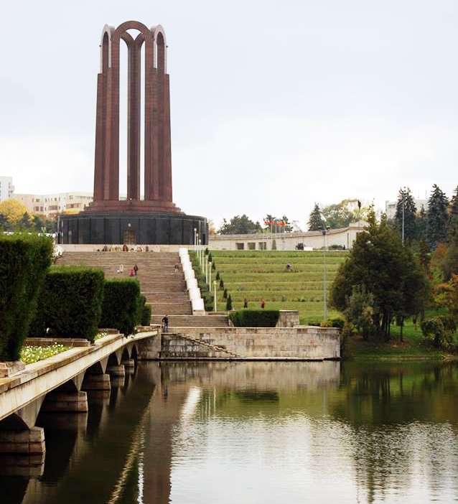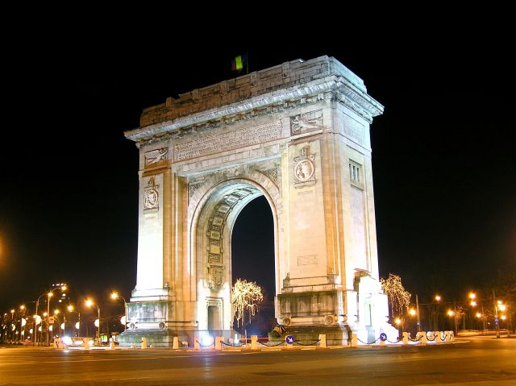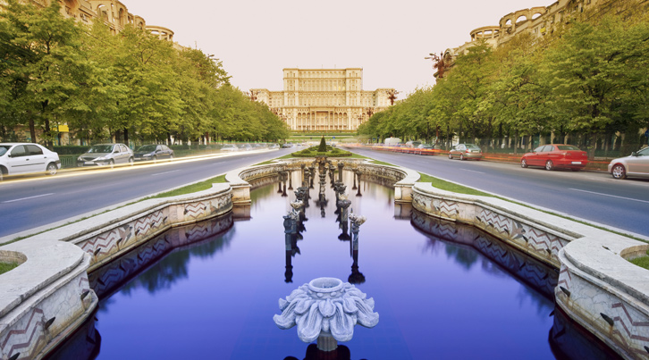

See more
Meanwhile in Bucharest - Short Documentary: https://www.youtube.com/watch?v=FrpwVDb5Dv4
Bucharest information: http://www.inyourpocket.com/country/romania.html
Virtual tour: http://www.panoramax.ro/bucuresti-panorame-virtuale.php

March 2018, Bucharest

Dear candidates for short term projects,
please full fill the form following this link: https://docs.google.com/forms/d/e/1FAIpQLSdsIx4Irc_T8K8XjUG_03v828qKVQtGjNM1m5t0TgWLZQgS4A/viewform
We will contact you for interview stage and if you will be selected:
soon you will arrive in Bucharest. As you know your project will be 6 months long. Therefore, we would like to give you more information for your EVS period. You will have the possibility to meet many other EVS volunteers from all over Europe.
They are in Bucharest supported by other parallel projects.

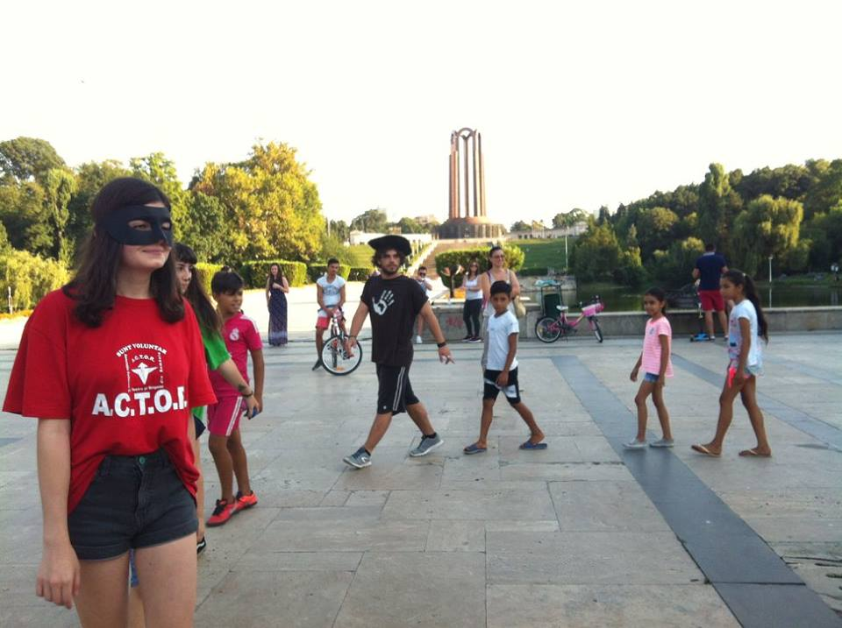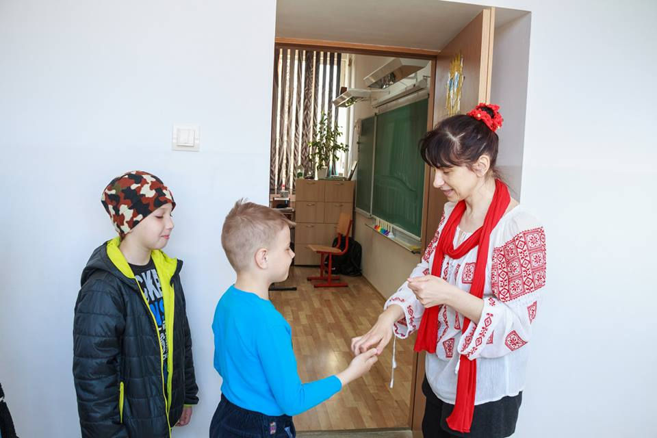

Now, we would like to tell you more about the activities you are going to have during your project here in A.C.T.O.R.

A.C.T.O.R. is using a large spectrum of art tools in young generation education and for social changes. Origami, but also puppetry, shadow theatre…etc are always methods in our volunteers toolbox. In the same time we are aware that are kids and youngsters with few opportunities who do not have access to any kind of artistic or cultural event.

The project’s goal to develop a program targeting the increase of parents' awareness about their role as active citizens in relation with the educative institutions.

PaC's OBJECTIVES:
1. to help the EVS volunteers to understand the values of active citizenship by doing efforts to stimulate parents to understand their community responsibilities in being more involved in the schools' life of their children.
2. to increase the awareness of the EVS volunteers about the importance of the sense of initiative and active participation as well as their skills by fostering the cooperation between parents and educative institutions.
3. to develop their competences and a greater understanding of the UE values by sharing their cultural diversity and reaching the awareness of the existence of different teaching and parenting methods, creating strategic actions for parents and schools to understand the educational process.
With their actions (discussions, workshops, toolbox, etc…) volunteers can contribute exchange among volunteers, children, parents and teachers. Volunteers can propose different and non formal methods to involve both parents and teachers in the activities with children because children learn by doing and playing and this is missing in the education system. As result everyone will gain and become a better citizen.

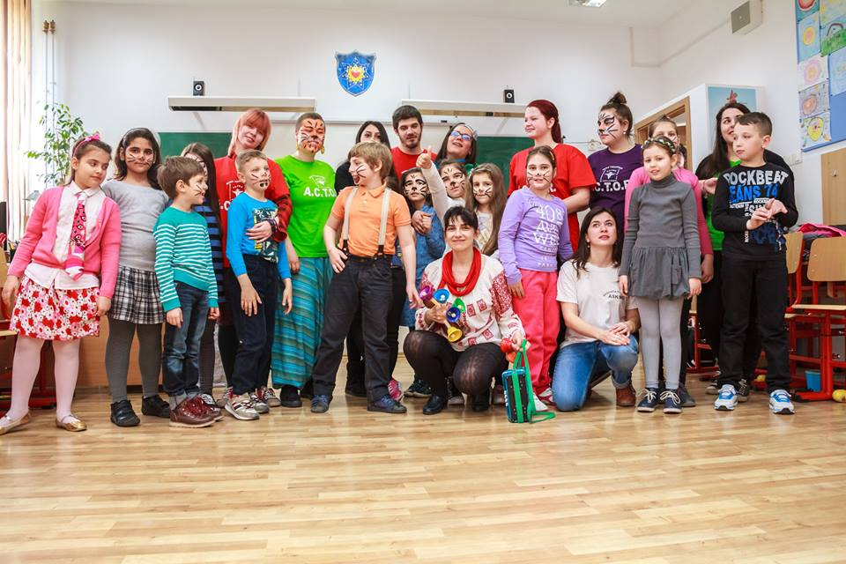

Tasks:
- Attending to trainings (On Arrival Training and Mid Term by National Agency and basic trainings in ACTOR about socio-cultural animator, ex. Balloon modelling, origami, puppet theatre, etc…);
- Designing and leading non-formal activities (in the field of art for education) for children, teachers and parents in schools (primary schools and kindergartens);
- Designing and leading clinical animation sessions for children & youngsters in hospitals & social centres;
- Promoting volunteering through non-formal activities and Forum Theatre sessions with youngsters;
- Organizing the Christmas campaign collecting toys for children & youngsters who are in hospitals & social centres;
- Running the visibility of the project (writing articles, managing the blog and the Facebook page of the project);
- Creating a toolkit about practices and non-formal activities for children engaging teachers and parents.

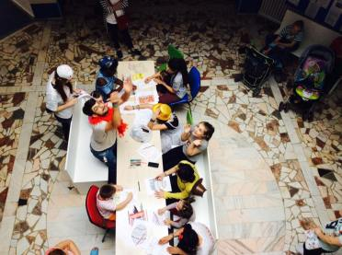

During the first two weeks you will receive some trainings to be prepared for the following activities. A.C.T.O.R. staff will assist you in this initial phase. You will also receive Romanian lessons by a very good teacher trained to work with youngsters with non-formal methods.

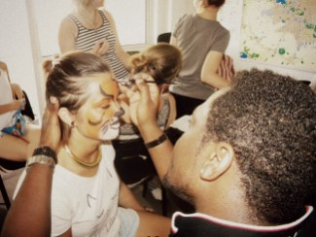

Since your selection you will be added to a Facebook group specially created by A.C.T.O.R. for internal communications among all volunteers. Every Friday you will receive the next weekly agenda (about 6 hours per day from Monday to Friday).
Every Thursday evening we will ask you to answer to some questions on a Google form specially created for your project. This will help us to monitor your learning process. Together we will have evaluation meetings the following day. These two tasks are compulsory not optional.

Accommodation & equipment
You will live in a flat (2-3 or 4 rooms) especially rented for volunteers. The apartments have 2 bathrooms and one kitchen. Everything you need for cooking facilities (pots, pans, cutlery) we have it. In the flats there will be some towels provided, but you are free to bring your personal ones. We don’t have computers in flats, but wireless internet access is provided, so if you have a portable computer that you want to bring you can have access, too.

Maintenance
Normally cleaning the house is your job, but we reserve our right to call a cleaning company once per month in your flat, which will be paid from your allowance, if you don’t keep the rooms clean. A cleaning company service for your apartment could cost around 15/20€ per person, if you will divide the cost between you. Each one of you will receive a key from the apartment. Please take care of it. If you will lose it we must change the all door mechanism. The one who loses the key must pay for this operation.

Boarding
Every volunteer will receive 60€ per month for food. In the common kitchen you can prepare the food by yourself or you can decide together the best solution to cook. Another 60€ per month will be your pocket money. Also more extra money 30€ will come at the end of every month. From this money we will keep just 10€ per month to buy in your place cookies, coffee, tea, fruits and salty snacks for the coffee breaks in the office.

Other payments
You will receive a bus-ticket per month for the whole town
of Bucharest, metro ticket and a phone card for Orange company (10€).
So, please bring your mobile phones with you.

Documents
All volunteers in A.C.T.O.R. need to provide a criminal record and medical analyses in order to prove to be suitable to work with vulnerable target groups, mainly kids in hospitals. These documents should be provided before the departure by scan copies and in original copy once here in Bucharest. So, please, don’t forget your criminal records and medical analyses!
Pay attention to all your travel tickets and boarding passes.
Also check if you have the signed agreement with you.

Holidays
Of course everybody has vacations. Every EVS working month will give you 2 days of holyday. You can decide yourself when is the best time for you, but will be good to inform A.C.T.O.R. in advance.

Weather
Summer months can be very warm, 40°-45°C and winter months very cold -10°/-15°C, so be prepared with the right clothes.
World times gateway: http://wwp.greenwichmeantime.com/time-zone/europe/european-union/romania/weather.htm

Arrival and the first days
Your arrival will be arranged some days in advance. One of our volunteers will come to pick you up from the airport, that is why we need to know in advance your arrival time and details about your flight. At the beginning the other EVS volunteers in A.C.T.O.R. will try to help you to find your way around in Bucharest, showing you how to use the bus and where the grocery stores are. Of course you will also receive a mentor, who will assist you for the entire length of your project and support you in your learning experience.

Anyway, below there are some basic information about life in Romania.

Currency
LEU (1€ = 4,64 lei);

Here are some prices:

Object | Price (lei) | Price (€)
Bread | 1,60 leu | <0,5€
Coca Cola 0.5l | 3,5 lei | aprox. 0.75€
Movie ticket | from 15 to 40 lei | maximum 10€
T-shirt | minimum 50 lei | around 7/15€ or higher

For Romanian usual expressions and their pronunciation, please visit
Romanian Language Translations: http://www.youtube.com/watch?v=VZK9sCeagNc;
Language tool: http://www.internetpolyglot.com/romanian/lesson-2104201130 (English-Romanian).

For emergencies
Stefanita Barbu - 004 0744 291474; stefanita.barbu@yahoo.com
Eugenia Barbu – 004 0744686093; actor_romania@yahoo.com
Silvia Tursi – 004 0744156295; silvia.tursi@hotmail.it
Antonio Lionetti – 004 0745011496; ant.lio88@gmail.com

So, if you have any further questions really don’t hesitate to call us, or to send us an email!
Hoping for a good start!
Until then, best wishes and see you soon!

A.C.T.O.R.’s team

